- Followed HyperionDev on LinkedIn
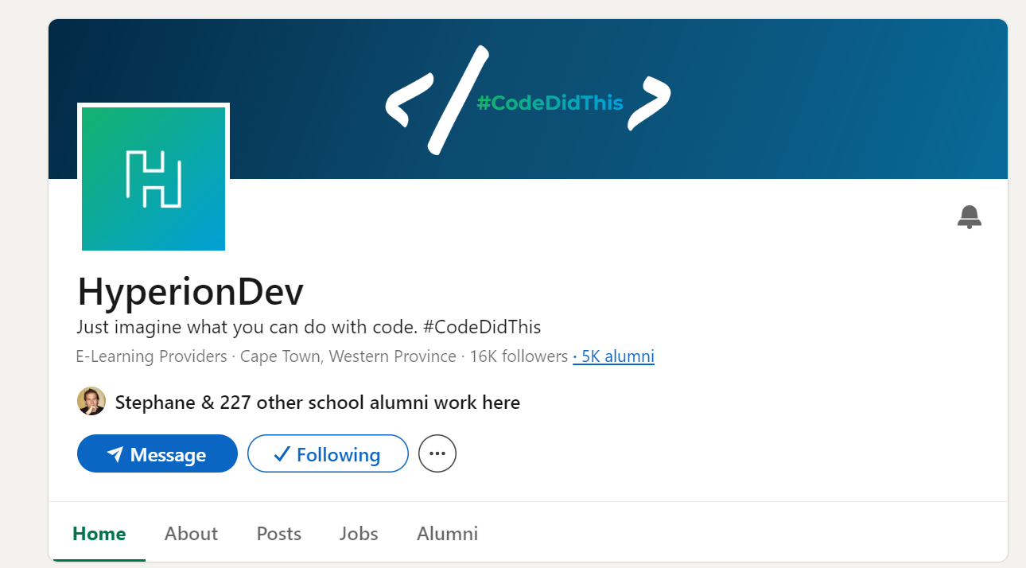
- Added Bootcamp to LinkedIn profile Education section
